**Virtual reality in selecting major**

**as a supported tool**

Nagham Alotaibi (202110560)

Raghad AL-Hindi (202120205)

Kinda Dardese (202110811)

Sara Mohammed (202111438)

Dr. Ahmad F. Shubita

# Abstract

The selection of a university major is often a challenging decision for students, primarily due to their limited exposure to real-world careers and the lack of personalized advisory support. Many students face uncertainty when trying to align their academic choices with their personal skills and interests. Traditional advising methods may not provide enough insight into the practical realities of various careers, leading to indecisiveness and misaligned choices. This study explores innovative approaches using Virtual Reality (VR) simulations and personality assessments to help students make more informed and confident academic decisions.The aim of this research is to investigate the integration of VR simulations and personality assessments as a comprehensive tool to guide students in selecting their university major. A mixed-methods approach was employed in this research to evaluate the effectiveness of VR simulations and personality assessments. Students were provided with immersive VR experiences, allowing them to explore various academic fields and gain practical insights into potential career paths. In parallel, personality assessments were conducted to generate personalized recommendations based on the students' traits and preferences. The effectiveness of these tools in reducing uncertainty and increasing confidence in major selection was evaluated through surveys, interviews, and data analysis. The study found that VR simulations significantly enhanced student engagement and provided valuable experiential learning, enabling students to better understand the practical aspects of different careers. Personality assessments also played an important role, offering individualized guidance and helping students better understand their personal strengths and preferences. However, limitations were noted in the predictive accuracy of major selection based on the data from personality assessments, primarily due to imbalanced datasets. This highlights the need for further refinement of predictive models and the improvement of data quality.  
The results of this study demonstrate the potential of VR simulations and personality assessments to transform academic advising. These tools provide accessible, engaging, and personalized career exploration, helping students make more confident and informed decisions about their academic futures. This research contributes to the development of innovative, data-driven solutions for student advising, while also raising important considerations regarding scalability, equity, and ethical implications. Further work is needed to refine the predictive models and improve the overall effectiveness of these tools in academic decision-making.

# .Key Words

Virtual Reality, Major Selection, Personality Assessment, Career Guidance, Educational Technology, Immersive Learning, Decision-Making Support, Higher Education, Student Satisfaction

# Introduction

Choosing a college major is one of the most important decisions students make, as it significantly shapes their academic and professional journeys. However, this choice often feels overwhelming and uncertain, with many students struggling to grasp the realities of different fields before committing (TechTarget, 2023). Current resources, such as career descriptions or interest assessments, provide limited insight, which can lead students to make choices that don’t align well with their interests, strengths, or career aspirations. This mismatch contributes to high rates of dissatisfaction, frequent changes in major, and sometimes even extended schooling, all of which can add financial strain and emotional stress (Raya, 2019).

Virtual Reality (VR) presents a promising solution by offering immersive, interactive environments where students can “step into” various career fields, from medicine and engineering to the arts. VR allows students to experience real-world simulations of different majors, providing a hands-on approach to exploring what each field entails (Makransky et al., 2020). Research has shown VR’s impact on enhancing engagement and comprehension in education, as immersive experiences help students connect with learning material on a deeper level (Serna-Mendiburu & Guerra-Tamez, 2024). For students, this method goes beyond theoretical understanding, enabling them to practically “try out” different roles and responsibilities before making an academic commitment.

Moreover, VR’s accessibility benefits expand its appeal. By offering virtual experiences, VR removes the logistical and financial barriers of traditional career exploration, such as shadowing or internships. This is especially valuable for students in rural areas or those who lack industry connections, as VR makes high-demand fields like healthcare, technology, and art more accessible (ClassVR, 2023). It levels the playing field, allowing all students to explore a wide range of fields without needing in-person experiences that can be costly or difficult to arrange.

While much of the existing literature highlights VR’s effectiveness in educational engagement and skill development, relatively few studies have explored its potential in supporting students’ decision-making during major selection (Hamad & Jia, 2022). To address this gap, our study investigates three main research questions:

1. How effective is a personality assessment application in accurately identifying personality traits and recommending suitable university majors?

2. How does a VR simulation influence users' perceptions of recommended majors and potential career paths?

3. How will the secondary data help us to predict the future major of the student and how much accuracy will be?

Specifically, we focus on whether VR and personality assessments can help students better understand the demands and opportunities of various fields, align their choices with their strengths and interests, and reduce the likelihood of changing majors down the road.

Ultimately, we aim to demonstrate how VR could transform the major selection process, empowering students to make choices they feel more connected to and equipped for. As VR technology becomes more accessible and sophisticated, its role in educational guidance could expand, potentially becoming an essential tool for students and advisors alike. Through this study, we hope to unlock VR’s potential to make the journey of choosing a major less daunting and more empowering, guiding students toward more satisfying and successful academic and career paths (Forbes Tech Council, 2024(.

## Research Questions

This section explores the intersection of technology, psychology, and education, focusing on how innovative tools like personality assessment applications and virtual reality (VR) simulations can empower students in their academic and career decision-making processes. By addressing three key research questions, we aim to evaluate the effectiveness of these tools in identifying personality traits, influencing user perceptions of potential careers, and reducing the stress associated with selecting a university major. This analysis will assess the overall efficacy of integrating technology into the academic advising process, with the goal of enhancing student satisfaction and success.

* Research Question # 1 (RQ1): How effective is a personality assessment application in accurately identifying personality traits and recommending suitable university majors?
* Research Question # 2 (RQ2): How does a VR simulation influence users' perceptions of recommended majors and potential career paths?
* Research Question # 3 (RQ3): How will the secondary data help us to predict the future major of the student and how much accuracy will be?

# Literature Review

1. How virtual reality technology has changed our lives: an overview of the current and potential applications and limitations:

Virtual reality (VR) technology has significantly developed from narrow specialties primarily focused on gaming to a versatile tool with broad applications among sectors such as education and healthcare. This literature review combines existing research on the applications, advantages, and limitations of VR technology, providing a complete understanding of its effect on modern society. Development in VR has enabled its combination into education, where immersive environments improve student engagement and information knowledge, and in healthcare, where mimicry allow medical professionals to train complicated procedures risk-free, thereby improving their skills and self-confidence. Additionally, VR is highly used in training programs across industries, giving safe plan for employees to be fit with high-risk tasks without real consequences. The main benefits of VR lie in its ability to give realistic simulations that ease experiential learning, leading to enhance memorizing of knowledge and skills, while widening many learning styles. However, although its promising applications, VR technology has various challenges, including user discomfort and dizziness from long headset use, high hardware prices that limit accessibility, and a decrease of standardization that can cause incompatible experiences.

The discovery of virtual reality (VR) as a helping tool for selecting academic majors is a growing area of research that carries great promise for improving students' decision-making processes. This crucial analysis tests the current literature on VR applications in education, especially focusing on how these technologies can help students in exploring their major selection. The relationship between VR and the major selection is clear in the trying experiences that VR can provide, making students familiar with many fields of study in a simulated environment. This aligns with research questions aimed at understanding how experiential learning through VR can affect students' perceptions and choices due to their academic tracks.

VR is able to create realistic simulations of different career environments, enabling students to imagine their possible futures and understand the skills requested for various majors. This experiential approach can greatly enhance students' comprehension of what each major involves, thereby simplify more informed decision-making. Although the promising applications of VR, there are marked gaps in the current literature. For example, there is a lack of experimental studies that assess the effectiveness of VR in enhancing decision-making results for students selecting majors. More serious research is needed to establish a clear connection between VR usage and students' comfortably with their chosen majors.

While VR has critical potential as a supportive tool for students in the major selection process, the existing literature focuses on both its benefits and critical limitations that need to be known through additional research. By exploring the potency of VR in decision-making, educators and researchers can better understand how to make this technology effective to support students in their academic tracks. This critical analysis serves as a base for future studies aimed at merge VR into educational practices, finally enhancing students' experiences and results in selecting their majors. (Hamad,2022).

1. The dark side of perceptual manipulations in virtual reality:

This paper was helpful in warning of dark side in the research on using VR as a supportive tool in educational field, as it critically studies the risks linked to Virtual-Physical Perceptual Manipulations (VPPMs). The results confirm the importance of ethical design and user safety, directly reporting the inquiry into the responsible implementation of VR in education.By marking the potential for harmful exploitation of VPPMs, the study confirms the need for guidelines that ensure VR applications improve learning experiences without compromising user safety. However, the paper has notable gaps, such as it relies on speculative design workshops without trial data to check the identified risks, and it lacks thoughts from end-users like students and educators. Future research could address these gaps by merge trial methods, such as user testing and surveys, to better understand the real-world consequences of VPPMs in educational contexts. The efficiency of the source is supported by its publication in a respectable conference known for strict peer review, as well as the authors' set up credentials in Human-Computer Interaction (HCI) and VR research. In general, this study offers a crucial foundation for perception the ethical implications of VPPMs, promoting the need for responsible design practices in educational VR applications. (Tseng,2022)

Figer1: dark side

1. Using 3D virtual environment as an educational tool in a Middle Eastern university:

The complementary of 3D virtual environments (VEs) in educational settings has received critical concern as institutions explore creative techniques to promote learning experiences and gain access. Studies reveal that 3D VEs provide unique advantages, particularly greater participating and interaction, by creating great experiences that reinforce a sense of presence between students. For example, Shubita and Issa studied the implementation of a virtual campus on the platform Second Life (SL) at the University of Petra in Jordan, where they observed a great increase in connection—up to 50% more than in classic classrooms—confirming how VEs ease rich communication and cooperation between students and educators .Also, 3D VEs enhance inclusivity by broaden educational access to individuals with special needs or geographical blockades. This aligns with research that reflects VEs' role in promoting critical thinking and problem-solving skills, basic for the recent workforce. However, these advantages, Shubita and Issa also set challenges, such as time consuming for skill enhancement and the need for trusted internet, both of which can obstruct the effectiveness of virtual learning. Their study confirms the need for optimize security and widen virtual services to improve user experiences, getting broader calls for treating limitations involved in VEs. This speech is mainly related to selecting a major, as VEs can serve as helping tools in students’ decision-making processes by providing realistic, great simulations of various academic tracks. Shubita and Issa’s research aligns with my question on how VR can help decision-making for major selection by let students to try different fields in a virtual environment. However, while Shubita and Issa present masked evidence of VE benefits, their focus still on general educational advantages rather than the specific role VEs could play in major selection. Future studies could title this by evaluate how students use VR for major exploration, possibly using case studies or polls to provide targeted visions on VEs' effect on decision-making. The reliability of Shubita and Issa's study is promoting by their expertise in software engineering and computer science, as well as their publication in a peer-reviewed journal. This, combined with references to high scored scholarly sources, offers a powerful base for comprehend VR’s educational potential. However, more research exactly targeting major selection would be worth to fully aware the advantages of VEs in improving students’ academic paths. (Shubita, Issa,2019)

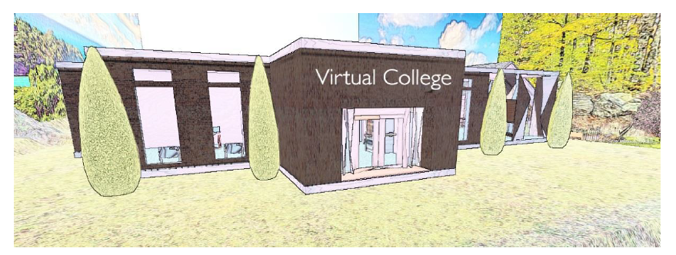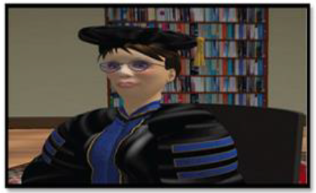

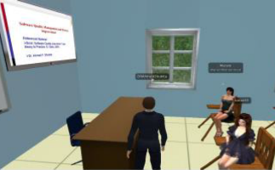

**Figer2: 3D environment**

1. Virtual Reality in Education:

Virtual reality has changed many of the conventional paradigms of education through this immersive and active learning environment. It intuitively illustrates knowledge of complex concepts through realistic simulations or abstract visuals, which one could see in virtual dissections in biology lessons or the re-creation of historical events in history lessons. It enhances students' knowledge retention by incorporating experiential learning theories in interactive, multimodal educational scenarios. (Yamamoto, G. T., & Altun, D. 2021)

1. Shaping the future of creative education: the transformative power of VR in art and design learning:

Studies on VR in creative disciplines emphasize the technology’s benefits in enhancing students' spatial and cognitive engagement. Serna-Mendiburu and Guerra-Tamez (2024) examined VR's role in art and design education, finding that improved usability and spatial navigation within VR environments significantly increased learning satisfaction. The application of constructivist principles underpins VR’s success in creative disciplines, as it enables students to build upon their knowledge interactively. This approach has been shown to positively influence both motivation and perceived learning outcomes (Serna-Mendiburu & Guerra-Tamez, 2024).

1. Face-to-face versus 360° VR video: a comparative study of two teaching methods in nursing education:

In order to assess how well 360° VR video teaches practical skills like closed tracheal suctioning, Babaita et al. (2024) compared it with in-person nursing education. The study found that although students in the two groups attained comparable levels of confidence, knowledge, and skill competency, the face-to-face group's pleasure was much higher. Although virtual reality (VR) provides an immersive and realistic experience, many students experienced symptoms of VR sickness, such as eye strain and discomfort, which affected their overall happiness with their education. However, because the VR technology allowed them to go over processes several times at their own pace, students in the VR group appreciated its realism and flexibility for self-directed learning. The results highlight 360° VR's potential as a supplement to traditional training methods in nursing, though they highlight the need for improved user comfort and technical refinement for broader adoption (Babaita et al., 2024).

1. Can an Immersive Virtual Reality Simulation Increase Students’ Interest and Career Aspirations in Science?

Makransky, Petersen, and Klingenberg (2020) explore the impact of immersive virtual reality (IVR) simulations on students' interest in science and STEM career aspirations. In two studies, they examine middle and high school students' responses to VR simulations of laboratory safety and DNA analysis. Findings indicate that IVR experiences significantly boosted science interest and self-efficacy across both age groups, with a notable increase in science career aspirations among female students aged 13–16. IVR’s immersive nature provided students with a realistic context for exploring complex science concepts, potentially bridging gender disparities in STEM fields. However, while interest and self-efficacy increased, lasting effects on career aspirations require longitudinal studies, highlighting the need for repeated IVR interventions to sustain these positive outcomes in science education (Makransky et al., 2020).

1. VR/AR technologies hold great promise in transforming radiology education and training:

The article by Mariana Yordanov delves into the roles of virtual and augmented reality (VR and AR) in radiology education and training, highlighting their growing importance. It reviews the current body of literature to highlight the advantages of these technologies, which include improved educational outcomes and the facilitation of interactive learning experiences. The application of VR and AR involves a range of tools, such as virtual dissection tables and three-dimensional imaging technologies, enabling students and residents to engage with and visualize intricate medical concepts in a simulated setting. Despite the promising educational benefits observed, there are still challenges related to the implementation and efficacy of these technologies. Additional research is required to substantiate their advantages in the realm of medical training. (Mariana Zhivkov a Yordanova (Kupe nova), 2024)

1. Summary:

While Virtual Reality (VR) has established itself as a powerful tool for enhancing engagement and comprehension across educational fields, its potential in supporting students’ decision-making processes, particularly in selecting a college major, remains relatively unexplored. The existing literature has focused primarily on VR’s effectiveness in teaching skills or enhancing specific knowledge, particularly in fields like the arts, science, and healthcare (Serna-Mendiburu & Guerra-Tamez, 2024; Makransky et al., 2020). However, there is a significant gap when it comes to understanding how VR might help students explore different academic paths and make more informed decisions that align with their interests, strengths, and career aspirations (TechTarget, 2023).

This study aims to address this gap by examining how VR can allow students to immerse themselves in virtual simulations of real-world work environments, offering them a hands-on, experiential approach to career exploration (Hamad & Jia, 2022). By providing students with a realistic preview of different majors, VR could help them make more confident and informed decisions, reducing the likelihood of dissatisfaction and major changes, which are often associated with extended study periods and increased educational costs (Raya, 2019).

The potential benefits of VR in this context are substantial, especially given its capacity to make career exploration more accessible. Students in remote or underserved areas, for instance, could gain exposure to a range of professions, overcoming geographical and financial barriers that limit traditional shadowing or internship opportunities (ClassVR, 2023). Moreover, VR's immersive learning experiences could support students in matching their academic choices with their personal strengths and interests, making the major selection process less daunting and more empowering (Forbes Tech Council, 2024).

At the same time, this study acknowledges certain limitations raised in the literature, including the issues of accessibility, potential discomfort with prolonged VR usage, and the ethical considerations necessary in VR design (Tseng et al., 2022). By keeping these limitations in mind, our research aims to provide insights into how VR could responsibly and effectively support students' academic planning and decision-making processes.

In conclusion, our findings suggest that VR holds transformative potential as a tool for academic advising, one that empowers students to explore fields in a meaningful and practical way. By addressing a gap in the existing literature, this study hopes to show that VR can be more than just a learning tool—it can be a valuable asset in helping students make choices that feel right for them, ultimately leading to a more fulfilling and purpose-driven academic and professional journey. As VR technology continues to advance, its role in education could expand, making learning and career exploration not only more accessible but also more aligned with students’ unique paths and goals.

While VR has proved possibility in education globally, a major gap still in the lack of experimental application and research in the Arab world. Existing studies have mainly emphasized on Western contexts, with restricted discovery of VR's effect on students in the Arab region. Future research should explore how VR could be helpful in local educational needs and integrated within Arab educational systems to optimize its advantages. Handling this gap would imply promoting localized VR applications that examine cultural and educational agents specific to the region, empower wider reach to VR as a decision-support tool for students searching academic and job options.

# Method

The methods section is an essential part of the research, as it provides the foundation for understanding the validity of the study. It describes the type of research conducted, how the data were collected, analyzed, and interpreted, and how the findings contribute to answering the research questions. Additionally, this section outlines how the reliability and validity of the sources were assessed. The following methods were employed in this research:

1. Type of Research and Data Collection:

The research is a mixed-methods study, combining both qualitative and quantitative data. The primary data sources are derived from a personality assessment application, feedback from users, and a VR simulation game designed to allow students to experience various university majors in an interactive environment. This combination of tools aims to assess how personality traits, preferences, and VR experiences influence students' decision-making about their university major.

* Case Studies: Case studies were conducted with a select group of participants who used the personality assessment and VR simulation to explore their major options. These case studies provided deeper insight into the decision-making process and how students navigated the tools.
* Personality Assessment Application: The personality analysis is based on a customized questionnaire that gathers user responses regarding their interests, skills, values, and preferences. The answers are then analyzed to recommend suitable university majors based on predefined criteria. This application is designed to help students identify their personality traits and match them with compatible academic disciplines.
* VR Simulation: The VR game allows students to explore different academic disciplines in a virtual environment, providing a hands-on experience of what each field entails. This simulation aims to help students better understand the practical realities of their chosen field, bridging the gap between theoretical knowledge and real-world application.
* Feedback: Data were also collected through user feedback to assess the effectiveness of both the personality assessment and the VR simulation. Feedback was gathered on how well students felt the tools helped them make an informed decision about their academic path and how they perceived the experience.

1. Data Analysis and Interpretation:

The data were analyzed using both qualitative and quantitative methods:

* Quantitative analysis: The personality assessment application generates scores and recommendations based on user responses, which were statistically analyzed to determine correlations between personality traits and recommended majors
* Qualitative analysis: Feedback from users was analyzed qualitatively to identify patterns, such as common concerns or positive experiences. Case studies were analyzed to explore the personal narratives of students and how the tools influenced their academic choices.

# Results

This section presents the study's findings, focusing on evaluating how Virtual Reality (VR) simulations and personality assessment tools support students in selecting university majors. The results highlight that personality assessments offer moderate accuracy in identifying traits and recommending suitable majors, while VR simulations provide immersive experiences that enhance students' understanding and confidence in their academic choices. Additionally, machine learning models showed limited predictive accuracy due to data quality issues, with Logistic Regression performing slightly better than other models. Overall, the findings emphasize VR's potential as an impactful tool for academic guidance, the value of personality assessments in initial evaluations, and the need for improved data quality to enhance predictive modeling outcomes.

## Research Question # 1 (Personality test)

To address this question, we developed a personality assessment application designed to evaluate students' personality traits based on a series of structured questions derived from psychological frameworks such as the MBTI (Myers-Briggs Type Indicator). The application analyzed students' responses to determine their personality type and then generated recommendations for university majors aligned with their identified traits.

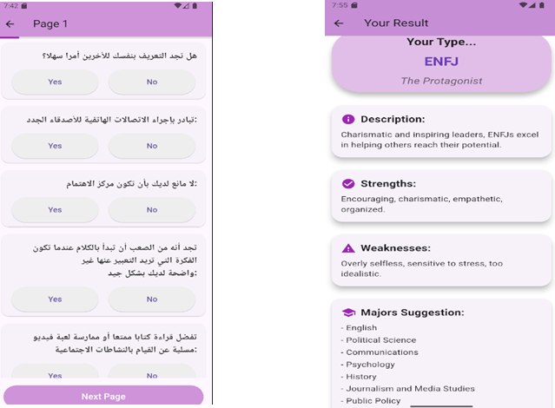

And the result was:

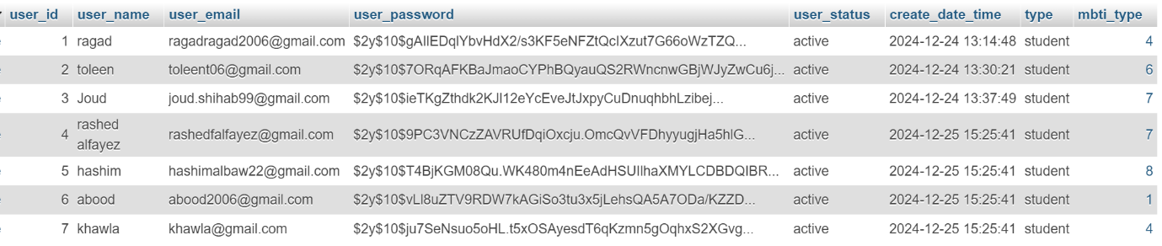

The feedBack result was:

## Research Question # 2 (VR simulation)

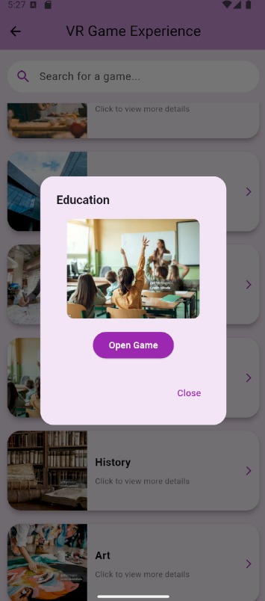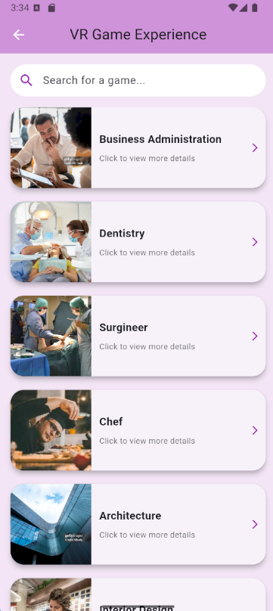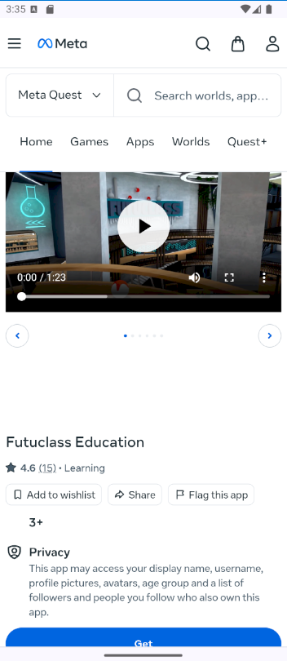

We developed a single VR simulation designed as a game that allows students to explore one academic field in an immersive and realistic way. This simulation was tested by a group of participants consisting of 3 males and 4 females. The game provided an interactive experience where participants engaged in representative tasks and scenarios related to the chosen field. While the current simulation focuses on one major, we envision expanding it in the future to include more fields for broader accessibility.

Findings

The VR simulation demonstrated a positive impact on participants' perceptions of academic majors and potential career paths. It allowed students to practically and realistically experience aspects of the field, helping them gain a clearer understanding and make more informed decisions.

Conclusion

These findings suggest that virtual reality is an innovative and effective tool to support students in their academic decision-making process. Although currently limited to one specialization, expanding this approach to cover multiple fields in the future could further enhance its value, making it an even more powerful resource for guiding students in their educational journeys.

## Research Question # 3 (Secondary data)

## Personality and career interest assessments are essential tools for helping students make informed academic and career decisions. The dataset analyzed in this study was collected between 2015 and 2018 through an online platform that administered tests based on the RIASEC/Holland Code and the Big Five Personality (TIPI) model. This rich dataset provides valuable insights into the relationship between personality traits and academic preferences, enabling a deeper understanding of how they influence individual choices.

## Source and Structure of the Data

## - Source: The data was collected from a globally accessible online platform, ensuring a wide demographic representation.

## - Components:

## - RIASEC: Measures career interests based on six dimensions: Realistic, Investigative, Artistic, Social, Enterprising, and Conventional.

## - Big Five (TIPI): Evaluates five major personality traits: Extraversion, Neuroticism, Openness, Agreeableness, and Conscientiousness.

## - Demographic Survey: Includes questions on age, gender, education, religion, and academic major.

## - Vocabulary Test (VCL): Assesses participants' attention and accuracy.

## Data Types

## - Quantitative: Numeric scores from RIASEC and TIPI tests.

## - Textual: Academic major information.

## - Categorical: Gender, education level, and cultural background.

## Data Cleaning Process

## Understanding and Exploring the Data

## Before analysis, we explored the dataset to understand its structure and properties:

## - Displayed the first five rows using `head()` to examine the layout.

## - Assessed data properties using:

## - `shape`: Revealed the dataset size (99,070 rows × 94 columns).

## - `isnull().sum()`: Identified missing values in each column.

## - `duplicated().sum()`: Found and removed duplicate rows.

## - `dtypes`: Checked data types for each column.

## Initial Observations

## - Several columns contained missing or irrelevant values.

## - Some columns, such as `surveyelapse`, `testelapse`, and demographic-specific data, lacked analytical significance.

## - Academic major entries were inconsistent, with variations in capitalization, symbols, and other formatting issues.

## Steps for Data Cleaning

## 1. Column Reduction:

## - Removed unnecessary columns like elapsed times, vocabulary checks (CL1-VCL16), and redundant demographic fields.

## - Reduced the total number of columns from 94 to 64.

## 2. Handling Missing Values:

## - Used `dropna()` to remove rows with missing values in critical columns, such as `major`.

## 3. Standardizing Text in the Major Column:

## - Applied `str.strip()` and `str.lower()` to unify text format.

## - Removed punctuation and numbers using regular expressions.

## - Filtered out non-English text.

## - Eliminated stopwords and expanded contractions (e.g., "can’t" to "cannot") using NLP libraries like NLTK.

## 4. Final Adjustments:

## - Ensured no entries remained empty after cleaning.

## - Reduced the number of unique majors from over 8,000 to a balanced subset suitable for analysis.

## Final Dataset

## - Refined and consistent dataset with 8,064 unique academic majors.

## - Clean and structured data ready for machine learning analysis.

## Predictive Modeling

## To predict students' future major choices, we applied three machine learning models. Initially, the dataset was imbalanced, leading to poor results. After balancing the top five majors, performance improved slightly, though data quality remained a limitation. The five selected majors were:

## - Accounting (223 samples)

## - Engineering (222 samples)

## - Mass Communication (217 samples)

## - Criminology (209 samples)

## - Art (194 samples)

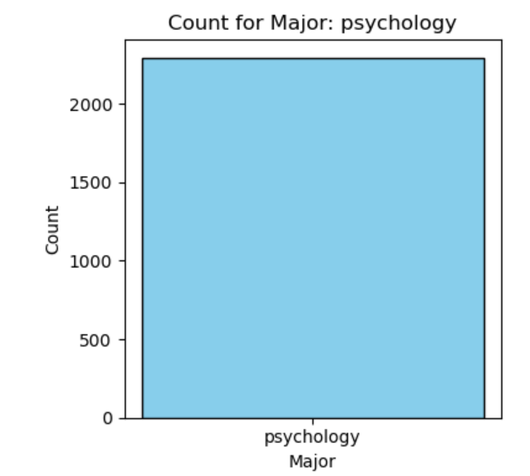

**Method 1: Logistic Regression**

* Approach:
  + The dataset was split into features (TIPI1 to TIPI10) and the target variable (the major).
  + 5-fold Cross-Validation was applied for model evaluation.
  + Logistic Regression was trained on the dataset.
* Results:
  + Accuracy per fold: [0.338, 0.333, 0.267, 0.356, 0.295]
  + Mean Accuracy: 0.318
* General Observations: Logistic Regression achieved the highest mean accuracy (0.318), but struggled with effective classification, indicating room for improvement in model performance.

**Method 2: Decision Tree**

* Approach:
  + The dataset was split into 70% training and 30% testing.
  + A Decision Tree Classifier was trained with a maximum depth of 5.
  + The model's performance was evaluated using the test set.
* Results:
  + Accuracy: 0.265
  + Classification Report: Low Precision, Recall, and F1-scores across all classes.
  + Confusion Matrix: Significant misclassifications, showing poor separation of classes.

General Observations: Decision Tree performed poorly with a low accuracy score (0.265). This could be due to insufficient depth or a lack of clear separability in the dataset.

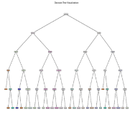

**Method 3: Gaussian Naive Bayes**

* Approach:
  + 5-fold Cross-Validation was applied.
  + A Gaussian Naive Bayes model was trained.
* Results:
  + Accuracy per fold: [0.295, 0.286, 0.267, 0.422, 0.258]
  + Mean Accuracy: 0.306
* General Observations: Naive Bayes showed comparable accuracy to Logistic Regression (0.306) but with more variability across folds, indicating inconsistent performance.

**Combined Results:**

| **Method** | **Accuracy per Fold** | **Mean Accuracy** | **Additional Observations** |
| --- | --- | --- | --- |
| **Logistic Regression** | [0.338, 0.333, 0.267, 0.356, 0.295] | 0.318 | Slightly better performance compared to other methods. |
| **Decision Tree** | - | 0.265 | Poor classification; significant overlap in predictions. |
| **Gaussian Naive Bayes** | [0.295, 0.286, 0.267, 0.422, 0.258] | 0.306 | Comparable to Logistic Regression but with more variability. |

**General Observations:**

* Logistic Regression achieved the highest mean accuracy (0.318), but still struggled with classifying the data effectively.
* Gaussian Naive Bayes showed a similar mean accuracy (0.306) to Logistic Regression but exhibited higher variability across folds, which suggests inconsistent performance.
* Decision Tree performed the poorest, with an accuracy of 0.265. This could be due to insufficient depth or lack of clear separability in the dataset.

**Conclusion:**

Although Logistic Regression achieved the best performance in predicting students' future majors with a mean accuracy of 0.318, the data quality remains a key limitation. The models showed poor performance overall, and further refinement of the dataset, particularly through better data preprocessing, rebalancing, or a specialized dataset relevant to Jordanian students, is necessary to improve prediction accuracy. Despite these challenges, the secondary data has the potential to provide valuable insights, but adjustments are needed in both data handling and model selection to improve the results.

# Discussion

## DISCUSSION ON RQ1

The personality assessment application yielded logical and reasonable recommendations, although they did not always correspond directly to students' current majors or preferred fields of study.

Observation-Based Insights:

* Students who indicated a preference for reality, structure, and scientific reasoning were frequently recommended majors such as Engineering. This outcome aligns with the logical and structured nature of engineering disciplines.
* A pharmacy student in her first year, whose aspiration was to study Medicine, received a recommendation for a Science-related major. While not directly aligned, this suggests an indirect relationship based on overlapping skill sets and academic foundations.

Gaps Identified:

* Some specific majors, like Pharmacy, were not explicitly covered in the application's recommendations due to limitations in the predefined dataset.
* The recommendations occasionally leaned toward broader academic categories (e.g., Science, Humanities) rather than specific disciplines.

Alignment Patterns:

* Personality traits linked to imagination and creativity tended to align with Arts and Design majors.
* Traits associated with analytical thinking and structure aligned with STEM majors.
* **Ethical Considerations**: The application should account for the ethical implications of certain careers. For example, medical fields require high ethical standards regarding patient care, while creative industries may emphasize intellectual property and artistic freedom.
* **Economic Factors**: It would be useful to incorporate labor market trends and economic viability when suggesting majors. For instance, majors related to technology and healthcare are more likely to have robust job prospects, aligning with current economic demands.
* **Social Implications:** The personality assessment app could influence students' decisions by shaping their perceptions of ideal careers. It may also reinforce societal norms about certain professions, potentially narrowing students' choices based on personality types rather than personal passions or emerging fields.
* **Technical Implications**: From a technical standpoint, the accuracy of the app depends on the robustness of its algorithms and the diversity of its dataset. If the dataset lacks representation for certain majors, it may lead to incomplete or skewed recommendations.

## DISCUSSION ON RQ2

The results of the VR game simulation suggest promising potential for using immersive technology to assist students in exploring academic majors. Here's a detailed discussion of the implications from social, technical, ethical, and economic perspectives:

* **Social Implications:**
  1. Improved Decision-Making: By providing students with an immersive experience, VR simulations can help reduce uncertainty and anxiety associated with choosing an academic major. This is especially significant in societies where education heavily influences career opportunities.
  2. Accessibility and Equity: Once scaled, such simulations could bridge gaps for students with limited access to career counseling or real-world exposure to certain fields, thereby promoting educational equity.
  3. Engagement and Interest: The gamified and interactive nature of the simulation can make learning about academic fields more engaging, potentially sparking interest in less popular or underrepresented disciplines.
* **Technical Implications:**
  1. Scalability: The development of simulations for multiple academic fields will require substantial technical resources, including field-specific expertise and advanced VR development.
  2. Usability Challenges: Ensuring the simulation is intuitive and accessible to students with varying levels of technological literacy is critical for its success.
  3. Hardware Requirements: The reliance on VR technology might pose a barrier if students lack access to compatible devices or face technical issues, necessitating alternative low-tech options.
* **Ethical Implications:**
  1. Bias in Representation: Care must be taken to ensure that the simulation presents unbiased, accurate, and inclusive representations of academic fields and associated tasks to avoid perpetuating stereotypes.
  2. Privacy Concerns: If data about students' interactions with the simulation is collected, robust measures must be implemented to ensure privacy and secure handling of personal information.
  3. Accessibility for All: Ethical considerations demand that the simulation is designed inclusively, accommodating students with disabilities and ensuring equitable access to the tool.
* **Economic Implications:**
  1. Cost of Development: Building and maintaining VR simulations can be expensive, requiring investments in technology, expertise, and updates to keep content relevant.
  2. Return on Investment: Schools, universities, and career counseling organizations could see long-term cost savings by using VR simulations as an alternative or supplement to traditional career guidance programs.
  3. Potential for Commercialization: A well-developed VR simulation tool could be commercialized for widespread use, offering both revenue generation opportunities and broader accessibility to the technology.
* **Conclusion:**

The VR game simulation presents a novel, impactful approach to academic decision-making. While the initial results are promising, the implications indicate the need for thoughtful scaling, attention to ethical considerations, and careful management of technical and economic challenges. By addressing these factors, this technology has the potential to revolutionize how students explore and choose academic and career paths.

## DISCUSSION ON RQ3

The results from applying machine learning models to predict students' future major choices reveal several insights and implications, particularly around the data quality, model selection, and performance limitations. Here's a breakdown of the findings and their implications across different dimensions:

* **Social Implications:**
  1. Personalized Guidance: If prediction models could be improved, this approach could offer students personalized suggestions about their future major choices, potentially leading to more informed and satisfied decisions. However, the current model’s poor performance means that relying on it for critical decisions could lead to inaccurate recommendations.
  2. Impact on Students’ Career Planning: For students, especially in regions like Jordan, the ability to predict and explore potential academic paths could aid in reducing uncertainty about their future careers. However, the current limitations of the model suggest that it could be misguiding if used without further refinement.
* **Technical Implications:**
  1. Data Quality: The performance of the models was hindered by issues in the dataset, such as imbalance and a lack of specificity (e.g., focusing on Jordanian students). This suggests that more relevant and higher-quality data is essential for improving prediction accuracy.
  2. Model Choice and Refinement: Logistic Regression, despite its higher accuracy, still had limited performance, indicating the need for more sophisticated models or enhancements, such as feature engineering, hyperparameter tuning, or ensemble methods.
  3. Scalability and Generalization: The relatively low accuracy and variability of the models point to the challenge of generalizing these predictions. Larger, more representative datasets would help in developing models that generalize better to unseen students.
* **Ethical Implications:**
  1. Bias in Predictions: The models might unintentionally perpetuate biases present in the data (such as demographic or socio-economic factors), leading to unfair predictions that could steer students toward certain majors over others based on these biases. Efforts must be made to ensure the data is representative of the full diversity of student profiles.
  2. Student Autonomy: If such models were used to make decisions about a student's academic future, it could inadvertently undermine students' autonomy, especially if the model were perceived as definitive rather than as one tool in a broader decision-making process.
  3. Transparency and Trust: It’s essential to ensure that students and educational institutions understand how these models make predictions. Lack of transparency in the model-building process might lead to skepticism or mistrust in the technology.
* **Economic Implications:**
  1. Resource Allocation: Improving the accuracy of these predictive models could help educational institutions better allocate resources for academic advising, potentially reducing costs associated with student counseling or decision-making support.
  2. Market for Predictive Tools: As predictive tools become more effective, there may be a growing market for these technologies, especially for educational institutions, ed-tech companies, and other stakeholders looking to enhance student guidance systems.
  3. Long-term Economic Benefits: Better predictions of students' academic interests could lead to higher retention rates, improved student satisfaction, and more efficient workforce planning. In the long run, this could contribute to a better match between academic fields and the job market, leading to reduced unemployment in saturated fields.
* **Conclusion and Future Directions:**
  1. Data Quality Needs Improvement: The primary takeaway is that the dataset's quality and relevance to the target population are critical to the model's performance. Further data preprocessing (e.g., rebalancing, addressing missing data, or adding more diverse samples) and using domain-specific data (such as one tailored to Jordanian students) could help.
  2. Model Enhancement: While Logistic Regression performed slightly better, all models need improvement. Exploring more advanced machine learning techniques like ensemble methods (e.g., Random Forest, XGBoost) or neural networks might yield better results.
  3. Data Collection: The dataset’s limitations underline the importance of gathering more representative data. This could involve surveying students in the target region (e.g., Jordan) or expanding to other regions for broader applicability.
  4. Future Potential: If the data and model can be refined, this predictive tool could be a valuable resource for students, helping them make better-informed decisions about their academic and career futures, especially if personalized to their profiles.

In conclusion, while the initial findings point to some potential, there’s a clear need for data refinement and model enhancement to make this tool viable for predicting students’ future major choices.

# Conclusion

Over the last couple of years, the trends in educational technology have changed in a manner that allows students to make critical academic choices in a different way. Virtual reality and personality tests are proving to be revolutionary technologies in this area, more so in assisting students in making decisions on which particular university major to pursue. The goal of this research was to assess the role of CVR and personality tests in improving students’ appreciation of fields they are exposed to and how those fields relate to their skills and preferences. To address this, this research evaluated three aspects: how well personality tests were able to identify students’ traits for recommending suitable majors, the use of VR simulations as a tool for interactive learning of specific aspects of academic fields, and applicable models on secondary data designed to explain students’ future behaviour’s. These results highlight the need of understanding the potentially career paths and how VR can enable deeper understanding in these areas. At the same time personality tests tell where shall we move: which academic area to cover. But there are still problems that need to be solved such as the data quality, insufficient coverage of fields in VR simulations, and the efficiency of the predictive models. In the end, this study emphasises how revolutionary the use of VR and personality tests in the process of academic advising can be. They help to combine theory and practice by providing direct exposure to situations which would be otherwise purely theoretical.

# References

*Al-Jufairi, M., 2020. اكتشف نمط شخصيتك القيادية حسب معايير MBTI*

*Babaita, A.O., Kako, M., Teramoto, C., Okamoto, M., Hayashi, Y., Ohshimo, S., Sadamori, T., Hattori, M., & Moriyama, M. (2024) ‘Face-to-face versus 360° VR video: a comparative study of two teaching methods in nursing education’, BMC Nursing, 23(199).*

*ClassVR, 2023. Virtual reality in Education.*

*Fisher, J.A. (ed.) (2021) Augmented and Mixed Reality for Communities. Boca Raton, FL: CRC Press.*

*Forbes Tech Council, 2024. Revolutionizing Education: The Impact of VR Headsets.*

*Hamad, A. & Jia, B., 2022. How virtual reality technology has changed our lives: an overview of the current and potential applications and limitations, International Journal of Environmental Research and Public Health, 19(18), p. 11278.*

*Jalalian, A. and Habibi, F. (2024). Virtual and Augmented Reality: Prospects in Radiology Education and Training. Journal of Radiology Technology Advances, 15(3), pp.123-137.*

*Makransky, G., Petersen, G.B., & Klingenberg, S. (2020) ‘Can an Immersive Virtual Reality Simulation Increase Students’ Interest and Career Aspirations in Science?’, British Journal of Educational Technology.*

*Raya, 2019. 64.7% work in jobs that do not match their university specializations.*

*Raymond, J., 2021. Top Majors & Careers for Your Myers-Briggs Personality Type. CollegeVine Blog.*

*Serna-Mendiburu, G.M. & Guerra-Tamez, C.R., 2024. Shaping the future of creative education: the transformative power of VR in art and design learning, Frontiers in Education, 9, p. 1388483.*

*Sun Education Group, 2021. MBTI Personality Types and Their Impact on Your Career. Sun Education Group.*

*TechTarget, 2023. What is virtual reality?*

# Appendix A

Personality test:

VR game:

FeedBack screen :

